**Report**

**Default Testing Credentials:**

**Email:** user

**Password:** 1234

**User Authentication:**

Users must log in to access certain features, such as the shopping cart and checkout process.

Unauthorized access attempts redirect users to the login page.

**Stripe Integration:**

The checkout process utilizes Stripe for payment processing.

Error handling is implemented to manage payment success/failure messages.

**Testing Approach:**

**User Registration:** Verify that users can create accounts with valid information.

**User Login:** Ensure that registered users can log in using correct credentials.

**Access Control:** Test that unauthorized users are redirected to the login page.

**Product Listing:** Confirm that products are displayed correctly with all relevant information.

**Filtering and Sorting:** Test filtering and sorting options to ensure they work as expected.

**Shopping Cart:** Verify that users can add and remove items from the cart.

**Cart Summary:** Ensure that the cart summary displays the correct total price.

**Checkout Process:** Test the entire checkout process, including order confirmation and payment processing.

**Payment Processing:** Ensure that payments are processed correctly using Stripe.

**Error Handling:** Test error scenarios, such as payment failures, and verify that appropriate error messages are displayed.

1. User Module
   * User Registration

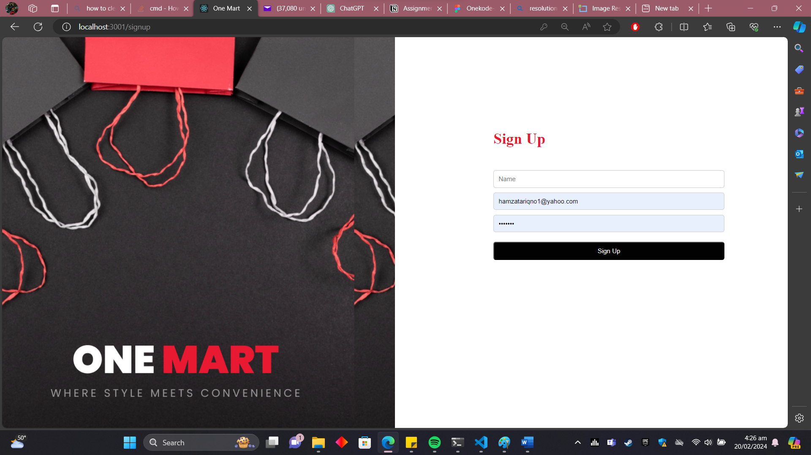

* + User Login.

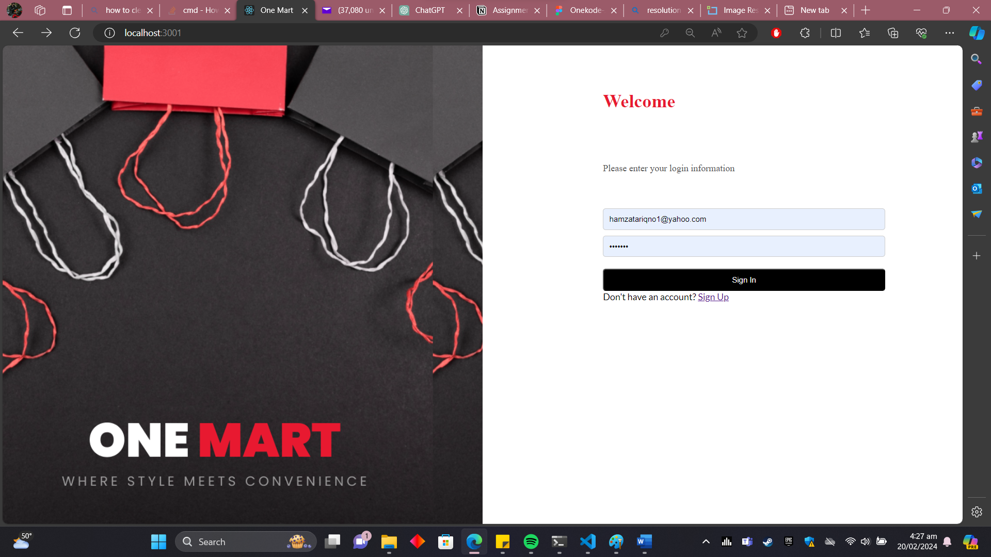

1. **Product Listing:**



1. **Shopping Cart:**

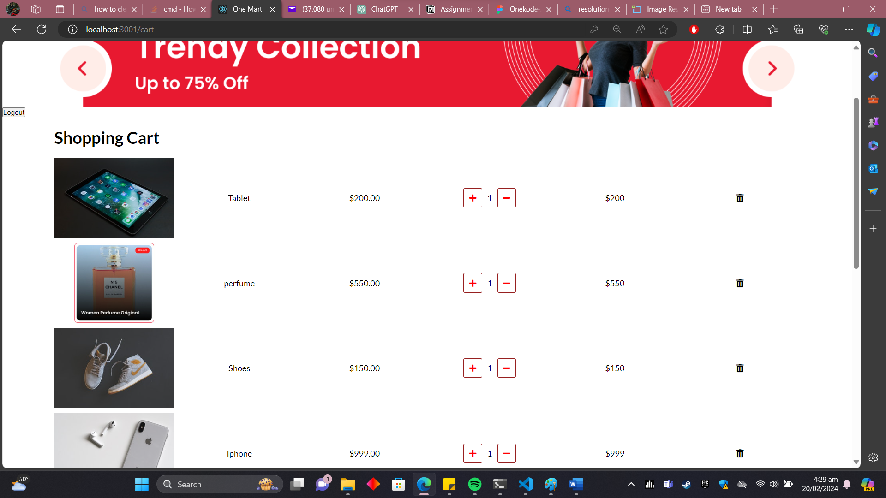

1. **Checkout Process:**

